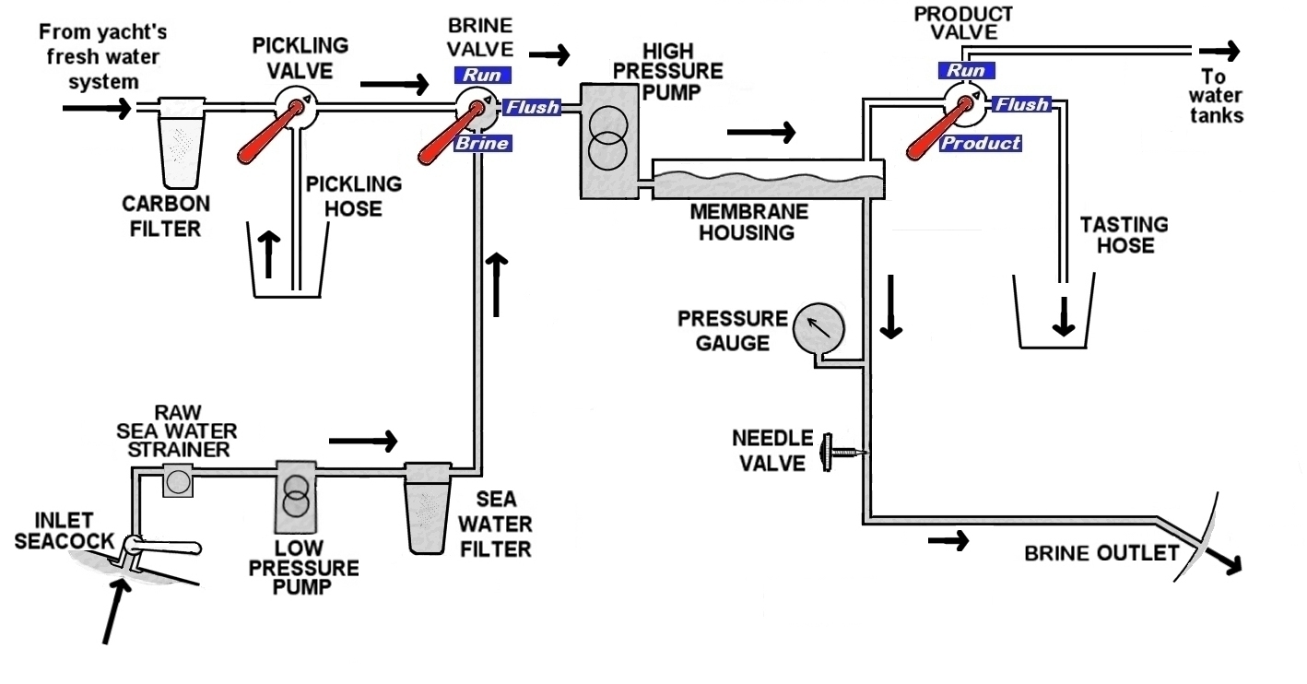
Making water
- Check the water quality to avoid clogging the sea water filter. Is Namadgi in clean water?
Don’t let anyone use the toilet to the sea or do the dishes.
- Ensure the batteries are close to fully charged before you begin.
- Start the Generator. The high pressure pump draws 1900 Watts and nearly double that on start-up.
- Switch off all other 240 volt appliances. Switch off the Battery Charger at the circuit breaker behind the radios panel. It overloads the Generator when making water. Turn them back on when you are finished.
- Switch on the Water maker 240 volt Circuit breaker.
- Isolate the Starboard water tank as a backup. Close the valve under the floor forward of the centre tank.
- Close Forward and Aft toilet outlet seacocks (outside heads under floor)
- Open Watermaker inlet seacock (under galley floor)
- Set Brine valve to RUN (lever vertical) (watermaker panel)
- Set Product valve to FLUSH (lever horizontal) (watermaker panel)
- Open Needle valve - 3 turns anti-clockwise
- Start the low pressure pump with the LO switch (left) above watermaker panel. Check water is flowing out of hull fitting next to generator exhaust. Check that water escapes from red bleed button on top of the saltwater filter and water is flowing in the plastic pipes. This can take a few minutes.
- If satisfied with water flow start the high pressure pump with HI switch (right) above watermaker panel.
- Check clear plastic pipes are clear of air bubbles. The bubbles can take minutes to clear.
- Place tasting hose (clear plastic with red stripe) into a container. Remove the stopper.
- Close the black needle valve slowly (turn clockwise) to raise the pressure to 700 psi. When pressure is stable, raise to 800 psi.
- Water will start to flow from tasting hose. Taste it. When satisfied with water quality set the Product Valve to RUN (lever vertical) to direct the product water to the yacht’s tanks. Replace the cap.
- Allow for 60 litres per hour, or more if the seawater is very warm.
- Stop making water by slowly opening the Needle Valve (turn anti-clockwise) until the pressure is close to zero.
- Turn off the LO and HI pressure pumps.
- At this stage you have the option to either Flush the watermaker or Pickle the watermaker. The watermaker must be pickled if it will not be used for 12 days or more. The easiest pickling method is to pickle immediately after watermaking.

Flushing the watermaker
- Remove the cap from the Pickling hose and place the hose in a container. There will be a small discharge.
- Set the Brine valve to FLUSH. (lever horizontal)
- Set the Pickling valve to FLUSH (lever horizontal). This will send water from the yacht’s filtered fresh water system through the watermaker for 2 minutes.
- Set the Pickling valve to RUN (lever vertical).
- Set the Brine valve to RUN (lever vertical).
- Replace the cap on the Pickling hose.
- Wash the seawater filter in galley tap water (Starboard wall of the engine compartment). Replace the filter if excessively contaminated.

Pickling the watermaker
- Dissolve five heaped tablespoons of sodium metabisulphite in a clean container of approx 12 litres of filtered water from the galley tap (or product water). Don’t breathe the dust.
- Place the Pickling Hose (clear plastic with red stripe) into the bucket and remove the cap.
- Pickling valve set to PICKLE (lever vertical) (Starboard side engine bay)
- Start the LO low pressure pump. Check water flow through pipes.
- Start the HI high pressure pump to pump the pickling solution through the watermaker.
- Set the Brine valve to FLUSH (lever horizontal)
- Switch off the LO low and HI high pressure pumps before the bucket has emptied. Do not allow the system to run dry.
- Wash the seawater filter in the remaining pickling solution.
- Return the Brine valve to RUN (lever vertical) and replace the cap on the Pickling hose.
- Close the Watermaker inlet seacock.
- Record date of pickling in your Skipper’s report.
- When all finished turn the Battery Charger back ON at the circuit breaker behind the radios panel.

Filters:
- The galley water carbon filter removes particles and chlorine from the yacht’s tank water. This is important because chlorinated town water will destroy the watermaker membrane, so when pickling use product water either from the watermaker tasting hose or water from the galley tap, which has a carbon filter. The filter is located in the cupboard under the sink and does not require cleaning.
- The watermaker flush carbon filter removes particles and chlorine from the yacht’s tank water for the flushing process. It is located under the floor outside the aft head.
- The sea water filter removes particles from the incoming sea water. It is located on the Starboard wall of the engine compartment. Clean it every time using filtered tap water from the galley tap or product water in the bucket. Replace the filter if it is excessively contaminated.
- The sea water strainer will remove large contaminants like seaweed and leaves. It is a round clear plastic screw cap filter located near the low pressure pump under the galley floor. Check it is clean.

